GEMINI PRO FINANCIAL DECODER
SmartBridge Virtual Internship Project

Team Details
Team ID: LTVIP2026TMIDS61777
Team Size: 5
Team Leader:
Baladithya Potti
Team Members:
B Sivanagaraju
Machavarapu Koti Sankar
Pandaraboina Phani Kumar
M Akhil Krishna

- INTRODUCTION
1.1 Project Overview
This project, titled “Gemini Pro Financial Decoder,” is developed as part of the SmartBridge Virtual Internship Program. The objective of this project is to analyze financial datasets and generate structured financial insights using Artificial Intelligence and Generative AI technology.
In today’s data-driven business environment, financial analysts and business owners often work with complex spreadsheets and financial statements. Manual analysis is time-consuming and requires expertise. This project provides an intelligent solution that enables users to upload financial data and automatically generate meaningful insights.
The system accepts financial datasets in CSV or Excel format. The data is processed and sent to Google’s Gemini Generative AI model, which generates structured financial summaries. The application demonstrates the real-world use of Artificial Intelligence in financial analytics and decision-making.

1.2 Purpose
The main purpose of this project is to apply theoretical knowledge of Artificial Intelligence, Data Analysis, and Python programming to build a practical real-world financial analysis application.
This project helps in understanding:
• API integration
• Web application development
• Financial data processing
• Prompt engineering
• AI model interaction
It also enhances technical, analytical, and problem-solving skills.

- IDEATION PHASE
2.1 Problem Statement
Many business owners, financial analysts, startup founders, and journalists need quick and structured insights from financial data. Reviewing financial spreadsheets manually requires significant time and expertise.
There is a need for a system that:
• Analyzes financial data automatically
• Generates structured financial insights
• Provides visual dashboards
• Is easy to use
This project solves the problem using Generative AI.

2.2 Empathy Map Canvas
What the User Thinks
• I need quick financial insights
• I want clear and structured analysis
• I do not want to manually calculate everything
What the User Feels
• Overwhelmed by complex spreadsheets
• Stressed before meetings or deadlines
• Confident when insights are clear
What the User Says
• “I need a summary of this financial report.”
• “This data is too complex to understand quickly.”
What the User Does
• Reviews spreadsheets
• Uses Excel for calculations
• Searches for financial interpretation
User Pain Points
• Time-consuming manual analysis
• Complex financial terminology
• Risk of calculation errors
User Needs
• Fast AI-generated insights
• Clear dashboard view
• Easy-to-use system

2.3 Brainstorming
Different approaches were considered:
• Manual financial dashboard using Excel
• Static financial report system
• AI-based financial insight generator
AI-based financial analysis was selected because it provides scalability, automation, and intelligent interpretation of financial data.

- REQUIREMENT ANALYSIS
3.1 Customer Journey Map
User workflow:
- User opens the application
- User uploads financial dataset
- System processes data
- AI generates financial insights
- Dashboard metrics calculated
- Charts and insights displayed

3.2 Solution Requirements
Functional Requirements
• Accept CSV and Excel financial files
• Process and validate financial data
• Generate AI-based financial insights
• Calculate dashboard metrics
• Display charts and summaries
Non-Functional Requirements
• Easy to use
• Fast response
• Reliable performance
• Secure API handling

3.3 Data Flow Diagram
User → Streamlit UI → Data Processing → Gemini API → Financial Insights → Dashboard Display

3.4 Technology Stack
Programming Language:
• Python
Framework:
• Streamlit
Libraries:
• Google Generative AI SDK
• Pandas
• Python-dotenv
Tools:
• VS Code
• GitHub
Platform:
• Windows OS
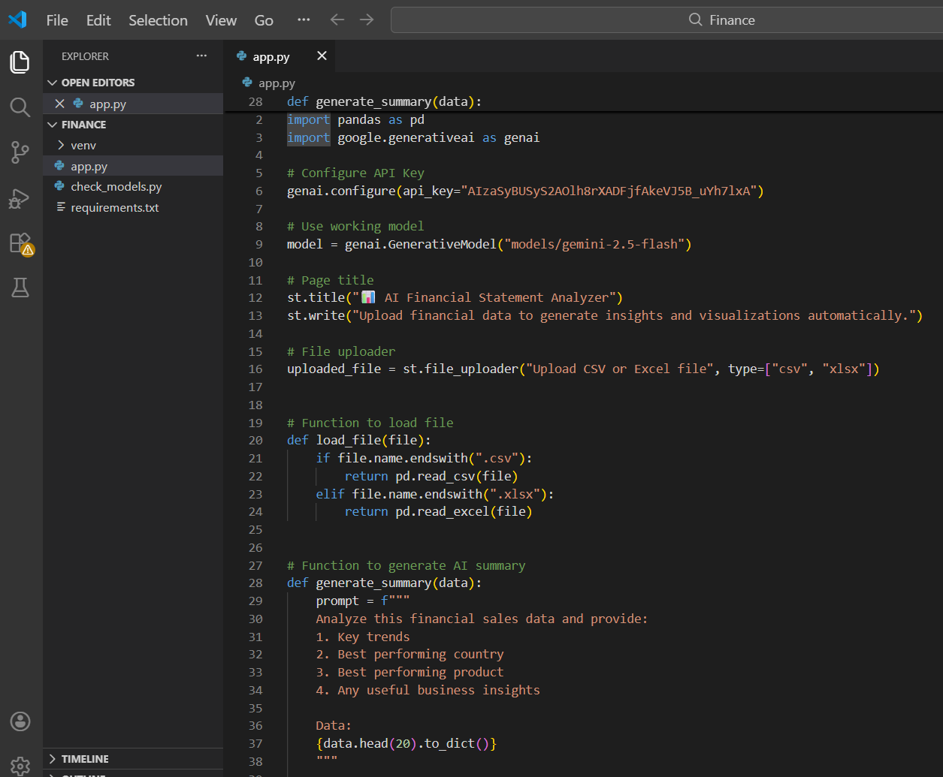

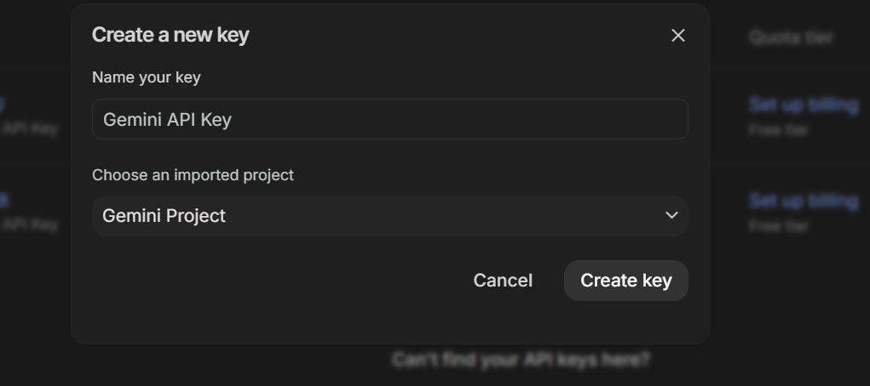

- PROJECT DESIGN
4.1 Problem–Solution Fit
The problem identified is the difficulty of interpreting financial data quickly and accurately.
The proposed AI-based solution automates financial data analysis and generates structured insights efficiently, reducing manual effort.

4.2 Proposed Solution
The system works as follows:
• User uploads financial dataset
• Data is processed using Pandas
• Structured prompt sent to Gemini
• AI generates financial insights
• Dashboard metrics calculated
• Charts and summary displayed

4.3 Solution Architecture
Components:
• User Interface (Streamlit)
• Data Processing Module (Pandas)
• API Integration Layer
• Gemini AI Model
• Dashboard and Visualization Module

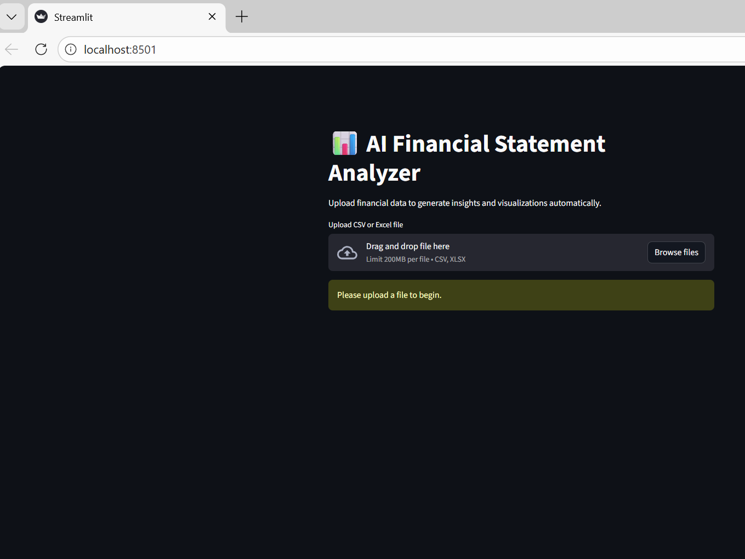

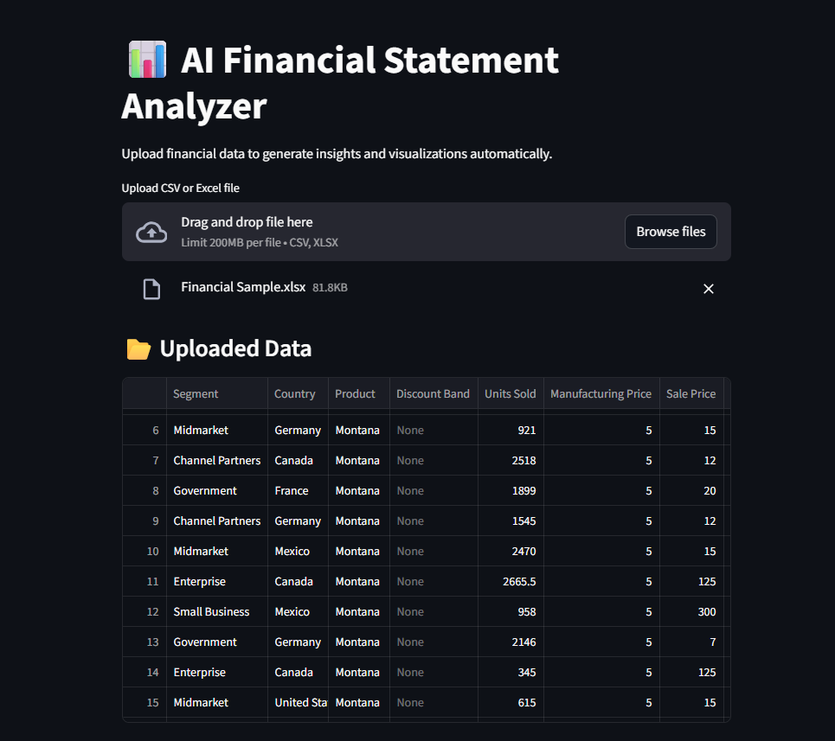
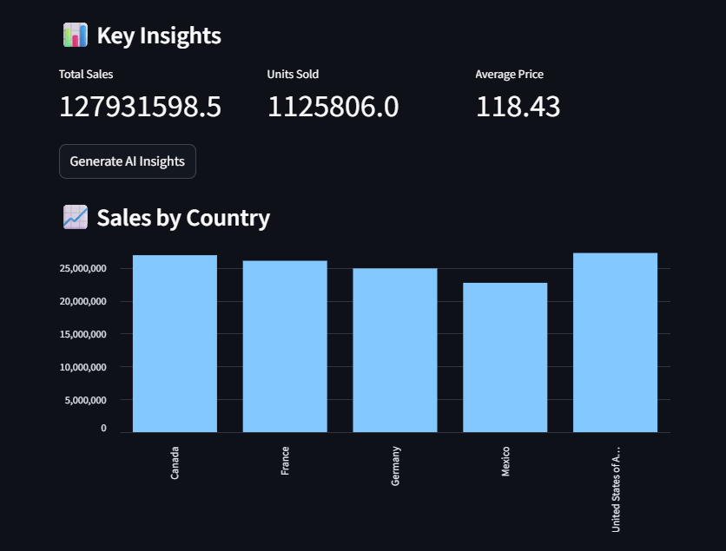
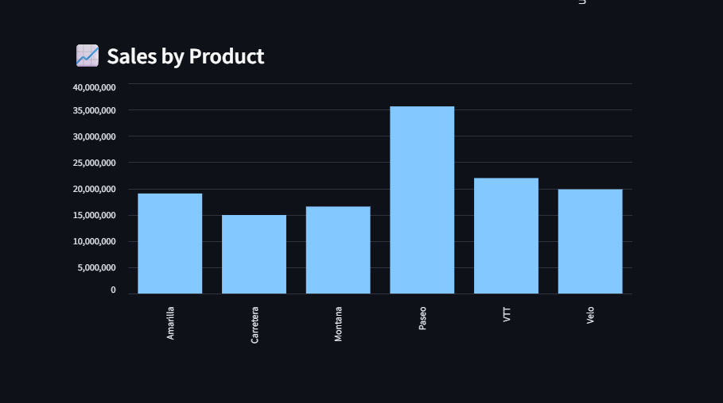

- PROJECT PLANNING AND SCHEDULING
Project Phases
- Requirement Analysis
- System Design
- Development
- Testing
- Documentation
Schedule
Phase 1 Requirement Analysis – 3 Days
Phase 2 Design – 3 Days
Phase 3 Development – 7 Days
Phase 4 Testing – 4 Days
Phase 5 Documentation – 3 Days

- FUNCTIONAL AND PERFORMANCE TESTING
6.1 Functional Testing
• Verified file upload
• Verified data processing
• Verified AI integration
• Verified dashboard metrics
• Verified chart generation
6.2 Performance Testing
• Checked AI response time
• Tested multiple requests
• Verified application stability

- RESULTS
The application successfully:
• Accepts financial datasets
• Processes data accurately
• Generates AI-based financial summaries
• Displays dashboard metrics
• Shows visual charts

7.2 Output Screenshots
Insert screenshots here:
Figure 1: Main Interface of the Application
Figure 2: Sample Financial Dataset
Figure 3: AI Generated Financial Insights

- ADVANTAGES AND DISADVANTAGES
Advantages
• Easy to use
• Fast financial analysis
• AI-powered insights
• Interactive dashboard
Disadvantages
• Requires internet connection
• API usage limitations

- CONCLUSION
This project demonstrates the integration of Generative AI with financial data analysis. The system successfully transforms complex financial data into structured insights and visual dashboards, providing a practical and intelligent solution for decision-making support.

- FUTURE SCOPE
• Multi-year financial comparison
• Financial ratio analysis
• PDF report generation
• Cloud deployment
• Enterprise-level dashboard

- APPENDIX
11.1 Security Implementation
• API key stored in .env file
• API key not hardcoded
• .env file ignored in GitHub

11.2 Project Demo
Demo Video:
(Insert Drive link here)

11.3 References
• Google Gemini API Documentation
• Streamlit Documentation
• Pandas Documentation
• Python Documentation

